If your life is in danger, get mean fast! If you can’t escape, you must fight. If you fight, fight to win, and don’t wait for them to hit first. Scratch, gouge, bite, kick, scream (LOUD), head-butt, strike with anything you have (purse, shopping bag, umbrella, etc.). There will be one winner and a loser. If you lose, it could cost you your life. SAFETY TIP: Women – your elbow is the strongest point on your body. If you are close enough to use it…DO IT!

Self Defense
Know Enough to Save Your Life

Things men look for in a potential female victim:

Someone they perceive will be any easy target and will not put up a fight.
Lack of Awareness. You MUST know where you are and what is going on around you.
Body Language. Keep your head up, swing your arms, stand up straight, walk energetically, and look people in the eye.
Wrong place…Wrong time. DON’T walk alone in any alley, or drive in a bad neighborhood at night. Don’t go into unlighted areas alone.
Serial killer Ted Bundy stated in an interview that he selected his targets based on whether they were alert and aware of their environment. If they were, he would look for someone else.

Someone walking or traveling alone, away from others.
Someone on their cell phones, searching through their purse, or doing other activities that occupy their attention and cause them to be distracted and off-guard.

Where attacks occur:

A primary place where women are abducted from or attacked is in public parking lots, like grocery stores, office parking lots, garages, shopping malls, etc.
Public restrooms.
Your home, or the home of a friend.

What the attackers are like:

They can look or act like anyone. They won’t necessarily look mean and nasty.
They may look and act nice. The might ask for directions, the time of day, they may pretend they know you, maybe they do know you, maybe they are related to you.
If in a public or exposed area, they are looking to grab a woman and quickly move her to a second location where they don’t have to worry as much about getting caught. DO NOT LET THEM GET YOU TO A SECOND LOCATION. HE WILL HAVE MORE CONTROL. YOU MAY BE RAPED AND/OR KILLED. FIGHT AS HARD AS YOU CAN AND SCREAM (LOUDLY) AS TO DRAW ATTENTION TO YOURSELF.
Reportedly, many attackers who claim to have a weapon actually do not. Rape or abduction with a weapon can result in a much longer jail sentence.
If you put up any kind of fight, they get discouraged. They don’t want the noise or the hassle of dealing with someone who will fight back. THEY WANT AN EASY TARGET – DON’T BE ONE!

What can you do to improve the odds:

The first step is to admit that it can happen to you. Remind yourself of this periodically when you are out shopping or walking. This awareness makes you more alert to potential danger.
Be aware of your surroundings. If you see any odd behavior, or if something just doesn’t feel right, don’t dismiss your instincts. If you sense something is wrong, stop where you are and evaluate your concerns. Don’t continue deeper into the situation, stop and get out, look for other people. You might feel silly at the time, but you’ll feel even worse if you walk straight into trouble.
Don’t get in a vehicle, or go anywhere with them. If there must be a fight, make it happen right there and then. Getting into a fight is scary, and the tendency is to put it off and hope it won’t happen, but if you go somewhere with them, you will end up in a location that is much more to their favor than where you started. RESIST… Don’t go along with them… RUN if you are able. DON’T EVER GIVE UP!

Use the weapons you have:

You have many weapons available and you can usually use more than one at a time. If you cannot use your hands, use another weapon – head, feet or your voice (yell strong, firm verbal commands).
Scream, head-butt or bite.
Block punches, grab, pinch, gouge, hit or scratch.
Use your elbows. Your elbows are the strongest part on your
body. If you are close enough to use it…DO IT!
Use your knees. Knee them in the groin or stomach.
Kick, stomp and most importantly…RUN, if possible!

Pointers about fighting:

If a fight starts, fight as hard as you can. Don’t just be defensive, take the initiative. Most people can’t go ten rounds like a trained fighter, and most street fights probably don’t last more than 30 seconds. Jump right in with all you’ve got – BE AGRESSIVE- Scream, scratch, hit, kick – FIGHT BACK!
Remember, “Eyes, Ears, Nose, Throat, Groin, Temple, Short Rib, Top of Foot.” These are the vital spots or targets you should concentrate on as they are somewhat easy to damage and you can quickly disable or discourage an attacker with one good strike to the right spot. Strike hard, strike fast, strike more than once, and strike more than one target.

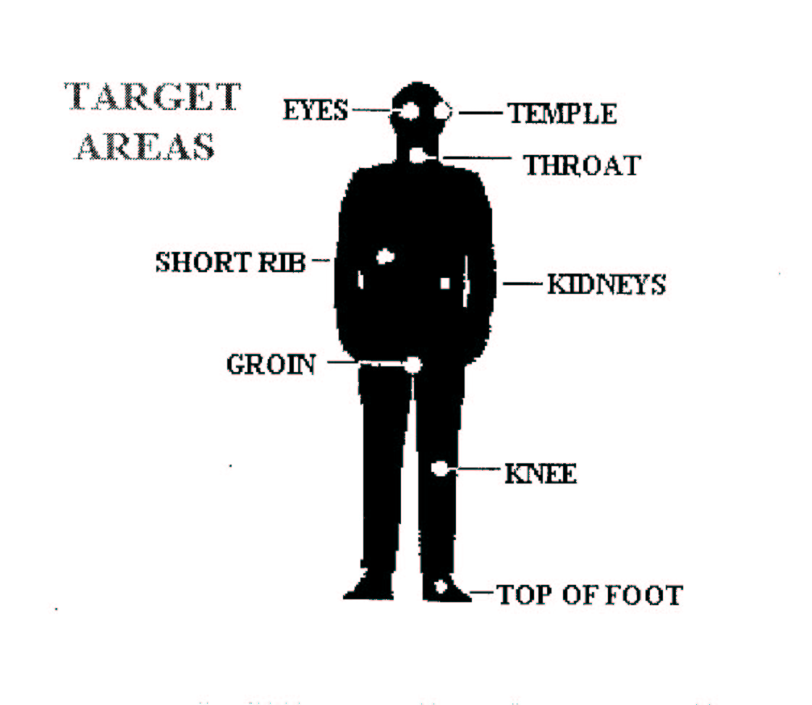

How to get out of threatening situations:

If someone is following near you or is with you in an elevator, look them in the eye and ask a question like what time is it, but do not flirt! If you observe them, you lose your appeal as a target because you can identify them later, if needed. Hit every button on the elevator and get off as soon as possible. Run to an area where there are people.
If someone is coming toward you and you feel threatened, yell “Stop” or “Stay Back.” Many attackers will leave you alone if they think you’re going to cause a scene. Remember, they are looking for easy targets, not a confrontation.
If someone grabs you from behind, pinch the attacker either under the arm, between the elbow and armpit, or in the upper-thigh area. Pinch hard, it is extremely painful. Strike the groin. Throw your head backwards into their nose. Stomp on their foot. Strike backwards with your elbow hard, hitting them in the ribs. Scream, scratch, bit, RUN!
Make initial hits to the head area, then strike the groin. Anytime you can grab a finger or two, grab them and bend them back as far as possible and with as much force as you can. If can cause much pain and you can break their fingers.
If an attacker grabs your clothing, try to slip out of it, then run to the nearest place where people are.
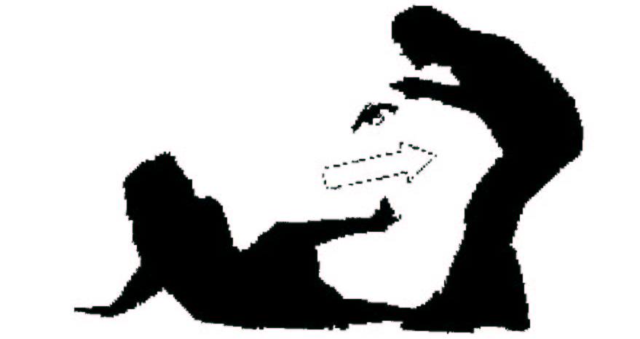
If an attacker knocks you down, try to escape and run away. If he knocks you down, shift to your side and kick with one leg at the attackers knee or groin.

If you are thrown in the trunk of a car, kick out the back tail lights, stick your arm out and start waving like crazy. The driver can’t see you but everyone else can. This has saved lives!
When walking to your car, look at the cars parked next to you. If a male in sitting alone in the seat nearest your car, walk back into where you came from and get a man to walk you to your car. (Better paranoid than dead).
When walking to your car, walk in an arc towards the back of your car, looking around and underneath before getting in your car. As soon as you get in your car, lock the doors.
If a predator has a gun, and you are not physically under this control, ALWAYS RUN! If he’s robbing you for your purse, throw your purse in the opposite direction and run. He’s robbing you for your money and will most likely go after the purse, not you. Police only make 4 of 10 shots, in range of 3-9 feet. This is due to stress. The predator will only hit you (a running target) 4 in 100 times. And even then, it will most likely not be a vital organ. RUN!!!

Final message…..

Be prepared to act and act hard!!! Have a plan. Not all things work on every person, have a couple of plans in mind.
You should think ahead of time about what you are willing to do to defend yourself and family members.
Remember the vital strike points.
The women who die EVERY MINUTE from violent crimes expected to go to bed that night, and wake up the next morning.

Only in the movies should the good guy let the bad guy hit first. Sometimes, one hit is all there is, and it’s over. How many hits can you take and stay in the fight? If you can tell something bad is going to happen, and there seems no other choice, strike first, strike vital parts, and strike hard. Better to be mistaken and face some sort of assault charge than to be incautious and be raped, beaten, or dead.
If you carry something like pepper spray, mace or some other kind of weapon, yell “I have pepper spray” or whatever. Holding the item in clear view can be a major deterrent.

